**NSSA221 Systems Administration I**

**Lab 03 Report**

# Name: Marveh Mustafa - Rania Kanaan - Suhaila Alfalasi - Saeed Falaknaz - Alia AlYammahi Grade ____/50

Use this template to answer questions related to Lab 3. Submit this template to the Lab Report 03 (LR02) drop box by the due date. Late submissions are subject to a 20% penalty. You must use this template and submit the document in Microsoft Word or Adobe PDF any other format will result in a zero grade for the report. When submitting your document, please save it in the following format, use LR02, followed by an underscore, followed by the first initial of your first name in uppercase, and your entire last name with the first letter in uppercase.

Example: LR03_GArcoraci.doc.

**Question 1** (5 points)

When using SSH, what are the benefits of using key-based authentication? Are there any disadvantages? If so, what might they be?

Because it employs and utilizes a private key, key-based authentication in SSH is a considerably more secure means of protecting your data than the usual username and password technique. It also protects users from many other sorts of attacks, such as brute-force and dictionary attacks. The disadvantage of employing key-based authentication in SSH is that it is more difficult to implement than the usual username and password method (Horan, 2023).

**Question 2** (5 points)

What does the git config --global command do, and why is it important?

The "git config --global" command is used to configure global-level settings. Other configurations can be used in the git global command, such as the merge configuration, which is used to deal with difficulties that arise when you wish to combine two branches together. Using this command, you may also customize your git output, such as changing the color of your git values and so on. When it comes to working across several projects, the "git config --global" tool is fantastic; it makes working across multiple projects in your repository much easier (*Git Config | Atlassian Git Tutorial*, n.d.).

**Question 3** (10 points)

What is a Git commit message, and what is it used for? What are some of the rules regarding writing a Git commit message?

The git commit message records the modifications and changes that were made to the project. The git commit message is useful for documentation; you can save all the modifications you have made throughout the years. This will make it easier for the other developers to understand why you made these adjustments to your project. It is also beneficial for evaluating past work done on your project, which, as a result, could save precious time in the future. There are some rules to follow when writing a good commit message to make your git commit message more understandable. Keep your commit message short and to the point; the first line of your comment should not be more than 50 characters. Specifying the type of commit is also very useful; you can mention whether the commit is an update or a bug fix (Pina, 2022).

**Question 4** (10 points)

What are the differences regarding how Git stores information/data in a global Git repository versus a local repository? Thinks of “Blobs.”

A local repository is one that already exists or is saved on your computer. It might be a previously cloned repository or one that was cloned outside of SourceTree. There's no necessity to clone local repositories; instead, simply drag and drop their folders into the SourceTree interface, as suggested in the UI, to "drag and drop repository folders" into SourceTree so that they show in the UI. A remote repository is one that lives on another server, such as Github, GitLab, or any other server that supports Git repositories. This is the one you'll need to clone into your own system so that it can serve as a local duplicate of the remote repository (*What Is the Difference Between Remote Repository and Local Repository in Git?*, n.d.).

**Question 5** (10 points)

Explain the purpose of the /etc/passwd, /etc/shadow, and etc/group files and provide a brief description of the information they contain. What are the files and folders in /etc/skel, and (ls -A /etc/skel), what are they used for?

The "/etc/passwd" file is used to store information about a user, such as usernames and usernames. The file "/etc/shadow" is used to store information about encrypted passwords of users, they contain the expiration date of these passwords. The "etc/group" file is used to store information about groups, such as the members of those groups and their usernames. "/etc/skel" is a directory that is considered a skeleton directory for new users. When a new user account is created, all default files, such as the Bash Shell found in "/etc/skel", are moved to the user's directory. from the folder. The command (ls -A /etc/skel) is used to list all the files found in the skeleton directory (5.2 Lesson 1, n.d.).

**Question 6** (10 points)

What could be done to prevent someone from changing the root password in single-user mode? Hint: Think about how you might protect the BIOS/UEFI on a Windows device.

There are various ways you can use to prevent a user from changing their root password when in single-user mode. One such approach is to safeguard your BIOS/UEFI firmware by creating a password that prevents it from being accessed. You may reset your BIOS/UEFI settings, which will reset their passwords as well. Keep the password somewhere secure; doing so will considerably improve the security of your system and prevent outsiders from altering the root password (Hoffman, 2014).



Make sure to include all screenshots for the report. For each missing screenshot, you will receive a 5% penalty to the grade. If your screenshots do not have the required information and are illegible, blurry, or unreadable, will not receive credit. Any attempt to alter the information in the screenshots in any way is academic dishonesty, and you may fail the course.

All screenshots must be labeled, using the following titles.

**Figure 1** – Git Repository Verification

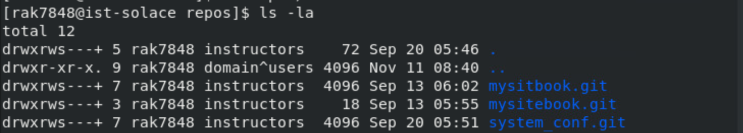

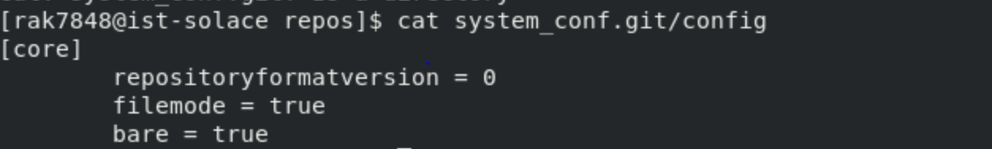

**Figure 2** – Git Log Revision History

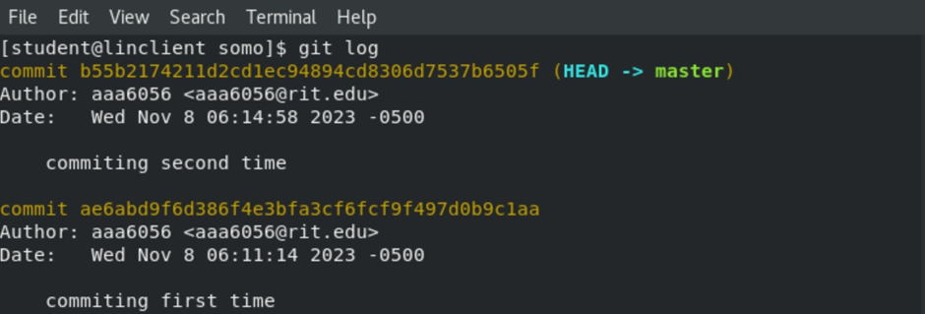

**Figure 3** – Git Merge Verification



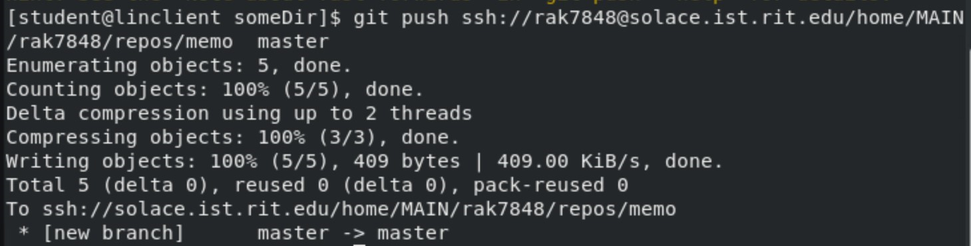

**Figure 4** – User Command History

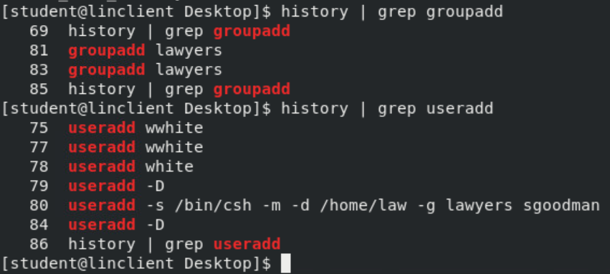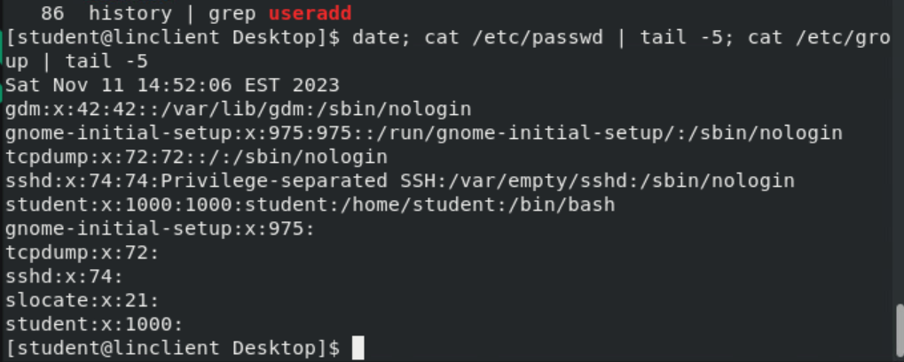

**Figure 5** – Root Password Change Verification

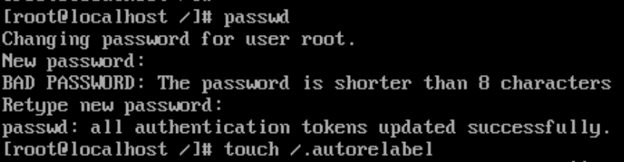

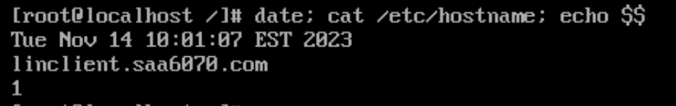

**References:**

Horan, M. (2023, August 24). Why Use SSH-Key Authentication Instead of Password Authentication? <https://www.sharetru.com/blog/why-use-ssh-key-authentication-for-sftp-instead-of-password-authentication>

*git config | Atlassian Git Tutorial*. (n.d.). Atlassian. <https://www.atlassian.com/git/tutorials/setting-up-a-repository/git-config#:~:text=The%20git%20config%20command%20is,modify%20a%20configuration%20text%20file>.

Pina, N. (2022, January 4). How to Write Better Git Commit Messages – A Step-By-Step Guide. freeCodeCamp.org. <https://www.freecodecamp.org/news/how-to-write-better-git-commit-messages/>

What is the difference between remote repository and local repository in git? (n.d.). Stack Overflow. <https://stackoverflow.com/questions/60825928/what-is-the-difference-between-remote-repository-and-local-repository-in-git>

5.2 Lesson 1. (n.d.). <https://learning.lpi.org/en/learning-materials/010-160/5/5.2/5.2_01/>

Hoffman, C. (2014, April 3). How to Secure Your Computer With a BIOS or UEFI Password. How-To Geek. <https://www.howtogeek.com/186235/how-to-secure-your-computer-with-a-bios-or-uefi-password/>